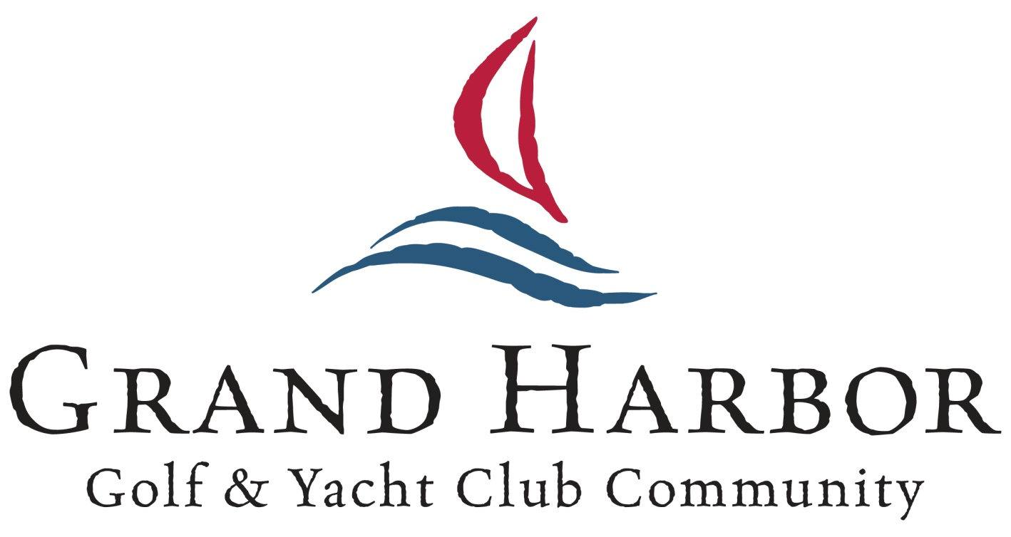

Weddings & Catering Menus
864.543.2440
grandharbor.net

Libby Brooks
Event Sales Manager 864-543-2440
libby@grandharbor.net

Banquet & Catering Services Fees & Policies

Grand Harbor Golf & Yacht Club Rental Fee

Saturday’s~$1,000 Friday’s~$750
“Off peak” - $500

This rental fee includes usage of the Golf Clubhouse, Lawn & Cabaana (if available) and includes:

- Wedding cake cutting and plating service
- Gold chivari chairs with ivory or black & gold chair pads
  - Tables, china, glassware and flatware
- Standard table linens and napkins in white, ivory or black

Ceremony Fee ~ $500
Fee includes the set up and breakdown of gold chivari chairs with white seat cushions and a one hour wedding rehearsal the day before the wedding.

Attendance Guarantees & Menu Selections
Final menu selections are due thirty (30) days in advance of your function.
Final attendance guarantees for all functions are due seven (7) business days prior to the start of your program.
The final guarantee is not subject to reduction should less attend.
If the actual attendance is greater than the guaranteed number, charges will be incurred based on the number of people served.

Pricing
All food & beverage prices are subject to a service charge of 21% and sales tax of 10.5%. Menu prices are subject to change up to 90 days prior to your event, due to fluctuations in food costs and product availability.

Deposits and Billing
A deposit of $1,000 is required to reserve your event date.
*After 30 days from your booking date your deposit becomes non-refundable in the event of cancellation.
This deposit will go towards your final bill.
The balance due (minus charges incurred during your event) must be paid four (4) business days prior to your event.
Any charges incurred during your event are due to be paid the night of the event
A valid credit card is required for security, but does not have to be the method of payment.
Grand Harbor Golf & Yacht Club accepts:
Cash, all major credit cards
and personal checks if submitted more than 7 days prior to your event.

Grand Harbor Golf & Yacht Club prohibits the use of confetti, silk flower petals or other non-biodegradable materials outside on the lawn, or for your reception exit. Bubbles, sparklers and fresh flower petals are welcome.

Plated Dinners

Chef’s Accompaniments, Club Salad, Fresh Baked Bread & Butter, Starch and Vegetable and Freshly Brewed Coffee & Iced Tea

Fish
Grilled Atlantic Salmon Filet with Lemon Herb Sauce $30

Crab Florentine Stuffed Flounder with Roasted Red Pepper Sauce $30

Pecan Crusted Salmon w/maple butter $32

Sautéed Grouper Filet “Oscar” Style $39

Chicken
Traditional Favorites
Marsala, Florentine, Francaise & Picatta $28

Almond Crusted Chicken Breast w/ pineapple teriyaki $28

Prosciutto Wrapped Chicken Breast w/ a roasted pepper cream sauce $29

Garlic and Herb Roasted Airline Chicken Breast With a white wine tarragon sauce $32

Shellfish
Shrimp & Grits
Sautéed Shrimp with Andouille sausage, peppers, onions in a white wine cream sauce over stone ground grits $32

Low Country Crab Cakes
two 4 oz. lump meat crab cakes w/ remoulade $38

Shrimp Scampi Provencal
White wine, tomato & garlic butter sauce over capellini $36

Pan Seared Sea Scallops
w/ a white balsamic beurre blanc $38

Beef
Spice Rubbed 12oz Ribeye $32

10 oz. Cut Prime Rib served with au jus $30 12 oz New York Strip $34
8 oz. Filet Mignon with a light Madeira sauce $37

Veal & Pork
Rosemary Brine Roasted Pork Loin with a White Wine and Whole Grain Mustard Sauce $28

Veal Scaloppini with Cherry Tomatoes, Capers, White Wine and Garlic Sauce $28

Marinated Grilled Pork chop w/ roasted shallot jus $27

New Zealand Rack of Lamb w/ mint jus $40

Vegetarian
Grilled Vegetable Pasta Primavera over penne pasta $25

Vegetable Napoleon with Parmesan Breaded Eggplant and Tomatoes Stacked with Spinach & Feta Cheese Served with a Vinaigrette Sauce $25

Marinated and Grilled Portobello Mushroom With Roasted Red Peppers and Asparagus w/ a pesto vinaigrette $25

Grilled Red Pepper Stuffed with Spinach, Sun Dried Tomatoes, Caramelized Onions, and Fresh Mozzarella Cheese $26

All prices subject to service fee and applicable sales tax

Starters, Soups and Salads

Starters
Chilled U-15 Jumbo Shrimp served w/ Cocktail Sauce and Lemon Wedge Jumbo Lump Crab Cake with Fried Green Tomatoes and a Sweet Corn Salsa Crab and Corn Fritters w/ sweet pepper remoulade
Duck Spring roll
micro greens & orange soy vinaigrette

Soups
Tomato Bisque $5 Butternut Squash $6 Minestrone $6 Classic She Crab $8
Corn and Shrimp Chowder $8

Salads
Your choice of Club Salad prepared with Romaine Lettuce & Baby Spinach w/ Tomatoes,
Sliced Cucumbers and Red Onions with choice of dressing or Traditional Caesar Salad w/ croutons & parmesan cheese
Dinner Duos
Grilled Chicken & Atlantic Salmon $33
Grilled 4oz Petite Filet Mignon w/roasted shallot jus accompanied by Marinated Grilled Breast of Chicken
w/ a roasted pepper champagne sauce $35 3 Grilled Jumbo Shrimp $38
3oz Crab Cake
w/ remoulade sauce $40 5oz Roasted Salmon $36
4oz or 6oz Lobster Tail steamed or grilled Market Price

CustomBuffets
Beef & Boar
Sliced Roast Beef au jus Marinated Flank Steak
Braised Beef Brisket Roasted Petite Filet (+$3)
Herb roasted Pork Loin w/ pan jus Pulled BBQ Pork BBQ
Marinated Grilled Pork Chop Smoked Pork Tenderloin (+$4)

Poultry
Almond Crusted chicken w/ pineapple teriyaki Prosciutto Wrapped Chicken w/ roasted rep pepper cream sauce
Marsala, sweet marsala mushroom sauce Florentine, white wine, spinach & parmesan cheese Francaise, lemon, white wine & cream
Picatta, white wine & capers sauce
Parmesan, freshly made marinara sauce topped w/ mozzarella & parmesan cheese Roasted Tom Turkey w/ homemade pan gravy
Herb Roasted Bone-in Chicken

Fish
Broiled or Blackened Talipia
Herb Roasted Salmon lemon basil vinaigrette Roasted Mahi Mahi w/ mango salsa (+$2)
Crab Stuffed Flounder Filet with Lemon Buerre Blanc (+$3) Pan Seared Grouper w/ a white balsamic vinaigrette (+$3)

Vegetables
Sautéed Baby Green Beans Spinach Gratin
Steamed Fresh Broccoli w/light butter Marinated Grilled Vegetable Medley
Parmesan Tomato Crowns Seasonal Vegetable Medley

Zucchini & Tomato Gratin

Starches
Yellow Squash Casserole

Garlic and Herb Roasted Red Potatoes Sour Cream Mashed Potatoes
Scalloped Potatoes Herb Rice Pilaf
Steamed New Potatoes Wild Rice Pilaf
Macaroni & Cheese Baked Penne Pasta w/ marinara or pesto

sauce
two entrees $38 or three entrees $46
Buffets Include Freshly Brewed Coffee & Iced Tea
All prices subject to service fee and applicable sales tax

Culinary Stations

Carving Stations

Carved Tenderloin of Beef Pepper Crusted New York Strip Roasted Petite Filet
Grilled Marinated Flank Steak Roasted Prime Rib Roasted Tom Turkey Glazed Baked Ham
Herb Crusted Leg of Lamb with Mint Jelly Roasted Pork Tenderloin

all carved items served with freshly baked rolls and condiments honey Dijon, horseradish cream, mayonnaise , Dijon mayonnaise

Action Stations

Pasta Station
Choice of two sauces w/sweet peppers, onions, mushrooms, sun dried tomatoes & parmesan cheese and choice of pasta
$11
Italian sausage & grilled chicken (+$3)

Low Country Shrimp and Grits
sautéed Shrimp with Andouille sausage, peppers, onions in a white wine cream sauce over stone ground grits
$13

Grilled Cheese Station
cheddar, swiss, provolone, American & Feta cheese toppings of tomato, onions, bacon & spinach
white, wheat & sourdough
$10

Stir Fry Station
two choices of beef, chicken, pork or shrimp
fried rice & lo mein w/ carrots, sweet peppers, onions, snow peas & broccoli
$13

Mashed Potato Bar
mashed potatoes with butter, sour cream, cheddar cheese, bacon bits, & chives
$10

all carving stations require a culinary attendant $75 And a minimum of 45 guests

Hors d’ Oeuvres

Fruits, Cheese & Vegetables

Prosciutto wrapped melon w/ balsamic syrup Brie and raspberry purses
Pimento cheese on crostini Vegetable Spring roll w/ sweet chili sauce
Spinach & feta cheese spanakopita Roasted vegetable tartlets

Beef, Chicken & Pork

Shaved Roast Beef on Crostini with Horseradish Sauce Beef Wontons
Grilled Beef skewers w/ ponzu sauce
Thai Style Beef Satay or Chicken Satay with a Spicy Peanut Dipping Sauce Bacon wrapped BBQ Chicken Bites
Chicken salad tartlets Mini Italian meatballs
Italian sausage stuffed mushrooms Sausage & cheese balls
Petite “BLT” Sandwiches

Seafood

Ahi tuna wonton w/ a soy ginger mayo Smoked salmon mousse on cucumber round Bacon wrapped shrimp or scallops
Shrimp canape w/ shrimp & herb cream cheese Bloody Mary oyster shooters, alcohol free Shrimp salad tartlets
Grouper fingers with cajun remoulade Mini crab cakes with remoulade Cucumber canapé with shrimp Individual shrimp cocktails

Culinary Displays

Sliced Fruit & Cheese Display
sliced fresh fruit w/seasonal berries & a honey yogurt dip
$10

Vegetable Crudités
fresh from the garden vegetables w/ creamy roasted garlic dip
$8

Artisanal Cheese Display
bleu cheese, aged cheddar, smoked gouda, pepper jack,
havarti dill, boursin, saged derby, cotswold, fontina, gruyere & baked brie w/ gourmet crackers
$13

Antipasto Display
prosciutto, capicola, salami and pepperoni,
assorted olives, artichokes, asparagus pepperoncini's and grilled vegetables fresh mozzarella gorgonzola, and provolone
artesian breads with extra virgin olive oil and aged balsamic vinegar
$15

Chilled Seafood Display
shrimp cocktail, oysters on the 1/2 shell, cocktail crab claws & cold water Lobster skewers
Market Price

Beverage Service

Bar Packages
Bar packages offer unlimited consumption and are charged for every guest in attendance over the legal drinking age of 21.
A list of available brands is available from the catering office

Premium Bar Package
$35

House Brand Package
$33

Beer and Wine Package
$30

Champagne available by request Soft Drinks & Bottled Water
$3 per bottle
Pine Lakes Country Club Alcohol Policy
In accordance with state la, alcoholic beverages will not be served to any guest under the legal drinking age of 21. All bars must be manned by Club staff, who may reserve the right to refuse beverage service to any guest who appears intoxicated or cannot produce proper identification. Identification will be requested of any guest of questionable age. Club policy prohibits the consumption of shots. No alcohol may be brought in or taken from the event by any guest. All private party bars are limited to a maximum of five (5) hours beverage service whether cash or hosted.

Bartender Fee
$100 per bartender for the entire event

All prices subject to service fee and applicable sales tax

